+91 9845728507 | srgreenscapes@gmail.com
Home | About Us | Services Overview | Process | Featured Portfolia | FAQ’S | Contact Us
Download Broacher

About Us | About Us
 | Vision & Mission
 | What Makes Us Different
 | Our Team
 | What Our Clients Are Saying

Landscaping PIC (1)
(Between this 2 pics matter will come)
(One Pic 2) About Us
SR Greenscapes Pvt Ltd is a science-driven sustainable landscaping company headquartered in Bengaluru, delivering integrated landscape and horticulture solutions across India.
Founded on the principles of Sustainability and Research, we combine plant science, soil health management, climate-responsive design and practical execution to create landscapes that are visually appealing, environmentally responsible and built for long-term performance.
Our services include landscape design and execution, softscape and hardscape development, irrigation solutions and professional maintenance programs. We also operate nursery and plant supply services, provide horticulture consultancy, offer green gifts, garden supplies and growing media, and design curated green décor and event styling solutions.
We believe landscapes should do more than beautify spaces- they should conserve resources, enhance biodiversity and add lasting environmental and economic value. From small home gardens to residential, institutional, commercial, airport, and resort projects, we deliver end-to-end green solutions—from concept to completion and ongoing care.
At SR Greenscapes, we don’t just build landscapes - we create sustainable ecosystems designed to thrive.
Sowing Science, Growing Beauty.

Vision
To become a nationally trusted leader in science-driven sustainable landscaping and horticultural innovation, creating climate-resilient green ecosystems that enhance biodiversity, improve quality of life and contribute to a greener future for India.
Mission
- Design, develop and maintain high-quality, research-based landscapes that are environmentally responsible and resource-efficient.
- Integrate scientific planning, native plant promotion, soil health management and water conservation into every project.
- Deliver reliable, end-to-end green solutions across landscaping, nurseries, horticulture services and sustainable infrastructure.
- Continuously innovate through research, field trials and professional expertise to create long-term ecological and economic value for clients.

What Makes Us Different
  Science-Driven Approach  Every project is guided by scientific assessment, including soil analysis, plant suitability studies, and climate-responsive planning to ensure long-term landscape performance. |   Sustainability at the Core  Our landscapes are designed to conserve water, improve soil health, promote native biodiversity and reduce long-term maintenance costs- creating environmentally responsible and future-ready green spaces. |   Research-Integrated Planning  Backed by academic expertise and field trials, we integrate innovation, performance evaluation and evidence-based plant selection into every project. |   Climate-Resilient Design  We develop adaptive landscapes that withstand heat stress, irregular rainfall and urban environmental pressures- ensuring durability and ecological stability.
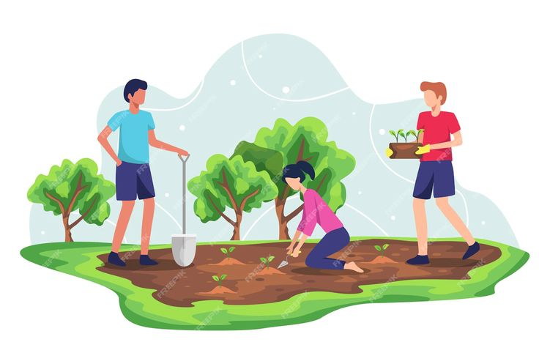  End-to-End Execution  From concept design and nursery production to irrigation systems and long-term maintenance, we provide complete, integrated green solutions under one roof. |   Experienced Leadership & Advisory Strength  Led by horticulture professionals and supported by a scientific advisory network, we bring institutional credibility and technical depth to every assignment. |   Long-Term Value Creation  Our focus is not just installation- but lifecycle performance, reduced resource use and sustained landscape health that delivers measurable value over time. |   Cost-Effective & Affordable  We deliver high-quality landscapes that balance performance, design and budget—ensuring maximum value through efficient planning, smart plant selection and optimized resource use

What Makes Us Different (Symbols and Same attractive design like home page)
🧪 1. Science-Driven Approach
Every project is guided by scientific assessment, including soil analysis, plant suitability studies, and climate-responsive planning to ensure long-term landscape performance.

🌱 2. Sustainability at the Core
Our landscapes are designed to conserve water, improve soil health, promote native biodiversity and reduce long-term maintenance costs- creating environmentally responsible and future-ready green spaces.

📊 3. Research-Integrated Planning
Backed by academic expertise and field trials, we integrate innovation, performance evaluation and evidence-based plant selection into every project.

🌍 4. Climate-Resilient Design
We develop adaptive landscapes that withstand heat stress, irregular rainfall and urban environmental pressures- ensuring durability and ecological stability.

🏗 5. End-to-End Execution
From concept design and nursery production to irrigation systems and long-term maintenance, we provide complete, integrated green solutions under one roof.

👥 6. Experienced Leadership & Advisory Strength
Led by horticulture professionals and supported by a scientific advisory network, we bring institutional credibility and technical depth to every assignment.

💰 7. Long-Term Value Creation
Our focus is not just installation- but lifecycle performance, reduced resource use and sustained landscape health that delivers measurable value over time.

8. Cost-Effective & Affordable
We deliver high-quality landscapes that balance performance, design and budget—ensuring maximum value through efficient planning, smart plant selection and optimized resource use

Our Team (One Pic- Only Name & Designation will be displayed)
The leadership and advisory team at SR Greenscapes Pvt Ltd combine academic excellence, field expertise and research-driven innovation to deliver sustainable and scientifically planned landscape solutions across India.
Managing Directors
Photo | Name & Designation | Description
Circular image of Dr. Supriya Narayan | Dr. Supriya Narayan  Managing Director | Leading SR Greenscapes with a vision rooted in sustainability, applied horticultural research and climate-resilient landscape development.
Circular image of Mr. Srinidhi AT | Mr. Srinidhi AT  Managing Director | Driving strategic planning, operational excellence and scalable execution of science-based landscape projects across India.

Scientific & Strategic Advisory Council
The advisory council strengthens our scientific foundation by guiding research integration, ecological planning and innovation-led project development.
Photo | Name & Role
Circular image of Dr. V. Nachegowda | Strategic Advisor (Former Director of Research & Dean, UHS Bagalkot)
Circular image of Dr. M. Chandregowda | Strategic Advisor (Member, Board of Management, UAS GKVK Bengaluru)
Circular image of Dr. P. Narayanaswamy | Strategic Advisor (Former Director of Research & Dean, KSUHAS Shivamogga)
Circular image of Dr. K. T. Rangaswamy | Strategic Advisor (Associate Dean, JCDR Agricultural College, Tadipatri)

Core Team
Photo | Name & Designation | Role Description
Circular image of Mr. Sanjay K | Mr. Sanjay K  Horticulture Expert | Providing technical guidance for landscape and horticultural projects
 | Yogish
 | Chaitra
 | Shruthi
Circular image of Vedashree S | Vedashree S  Botanist | Providing botanical expertise for plant selection and biodiversity-focused landscape development
Circular image of Pooja KM | Pooja KM  Civil Engineer | Designing and supervising civil infrastructure works for landscape projects
 | Bharath
Circular image of Ms. Pavithra K S | Ms. Pavithra K S  Business Development Lead | Driving brand growth and client engagement
Circular image of Ms. Vindya K | Ms. Vindya K  Accounts Manager | Managing finance, compliance and accounting operations
 | Pranathi
 | Ganesh A T
Circular image of Mr. Keshava M R | Mr. Keshava M R  Project Manager | Overseeing project planning, execution and quality control
Circular image of Mr. Venkatesh P V | Mr. Venkatesh P V  Field Supervisor | Coordinating on-site activities and workforce management
 | Mahesh

What Our Clients Say
Hear directly from our clients about their experience with us. Their satisfaction reflects our commitment to quality and excellence.
Their Message  ………………  …………………..  Small round pic  Name  Company/Designation/Profession | Their Message  ………………  …………………..  Small round pic  Name  Company/Designation/Profession | Their Message  ………………  …………………..  Small round pic  Name  Company/Designation/Profession
Their Message  ………………  …………………..  Small round pic  Name  Company/Designation/Profession | Their Message  ………………  …………………..  Small round pic  Name  Company/Designation/Profession | Their Message  ………………  …………………..  Small round pic  Name  Company/Designation/Profession
Their Message  ………………  …………………..  Small round pic  Name  Company/Designation/Profession | Their Message  ………………  …………………..  Small round pic  Name  Company/Designation/Profession | Their Message  ………………  …………………..  Small round pic  Name  Company/Designation/Profession
Their Message  ………………  …………………..  Small round pic  Name  Company/Designation/Profession | Their Message  ………………  …………………..  Small round pic  Name  Company/Designation/Profession | Their Message  ………………  …………………..  Small round pic  Name  Company/Designation/Profession

Request a call back Requirement
Name Phone City Landscape Design Execution
Specialized Garden Services

Submit

Softscape & Hardscape Development
Landscape Maintenance
Horticulture Consultancy
Green Gifts
Garden Supplies
Event Styling

About Us Follow Us
Based in Bengaluru | Services Links of Social Medias
Pan-India Project Execution Project Portfolia
Process
Phone: +91 9845728507, FAQ’s
+91 9113620609 Contact Us

Email: srgreenscapes@gmail.com
mdsrgreenscapes@gmail.com

